Custom Agent Policy & Adding Integration

**Each Elastic Agent can only be enrolled in a single policy**. Within an Elastic Agent policy is a set of individual integration policies. These integration policies define the settings for each input type. The available settings in an integration depend on the version of the integration in use.

1. Go to Management → Fleet → Agent Policies.
2. Follow the pics below:

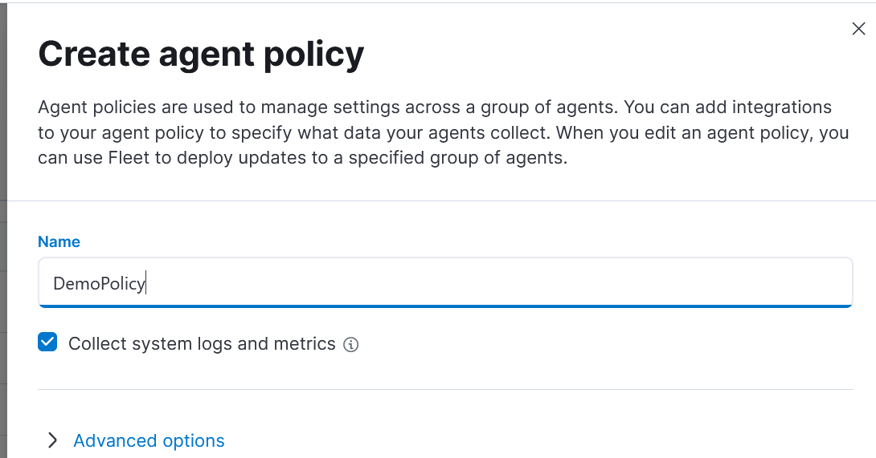

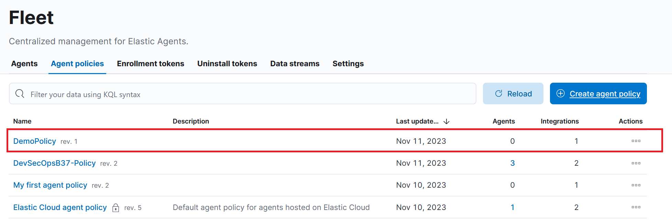

As you can see in the above screen for DemoPolicy we dont have any agents but one default integration. We need to add additional integrations.

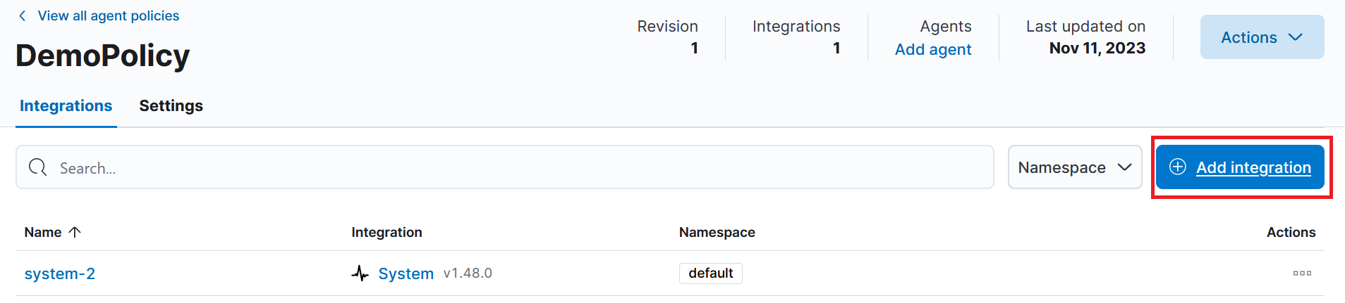

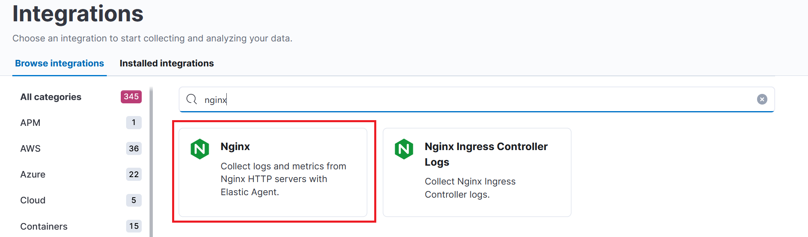

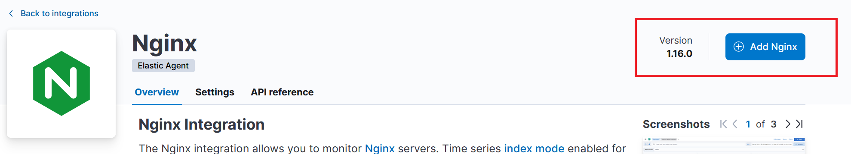

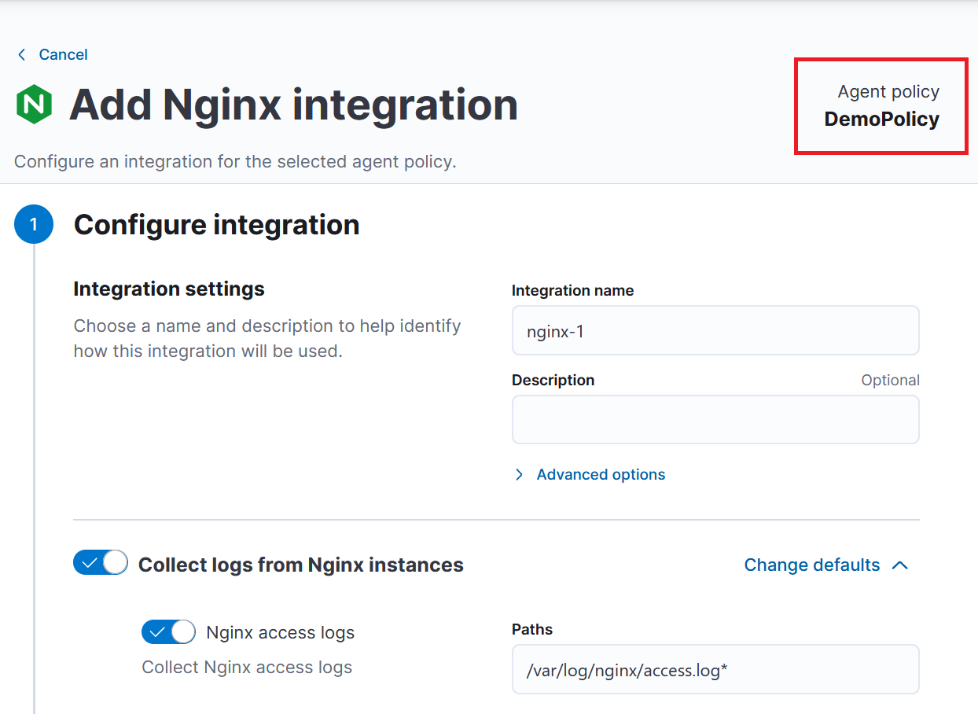

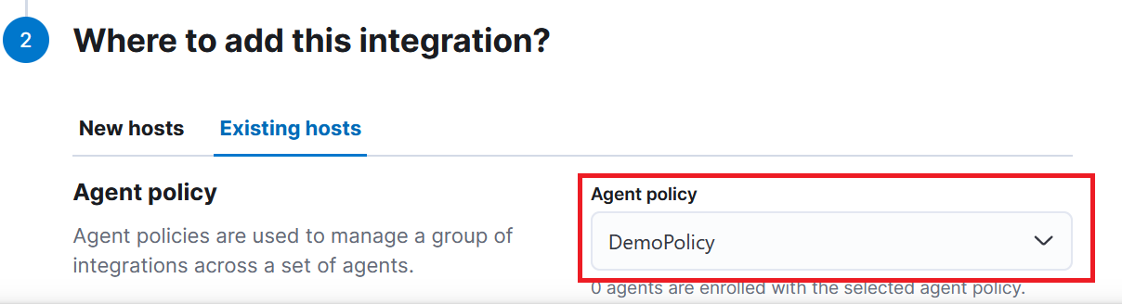

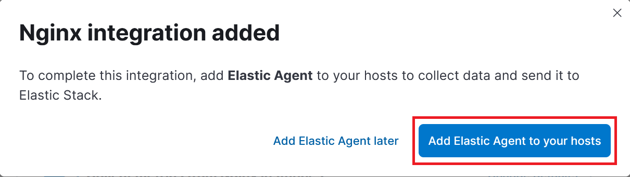

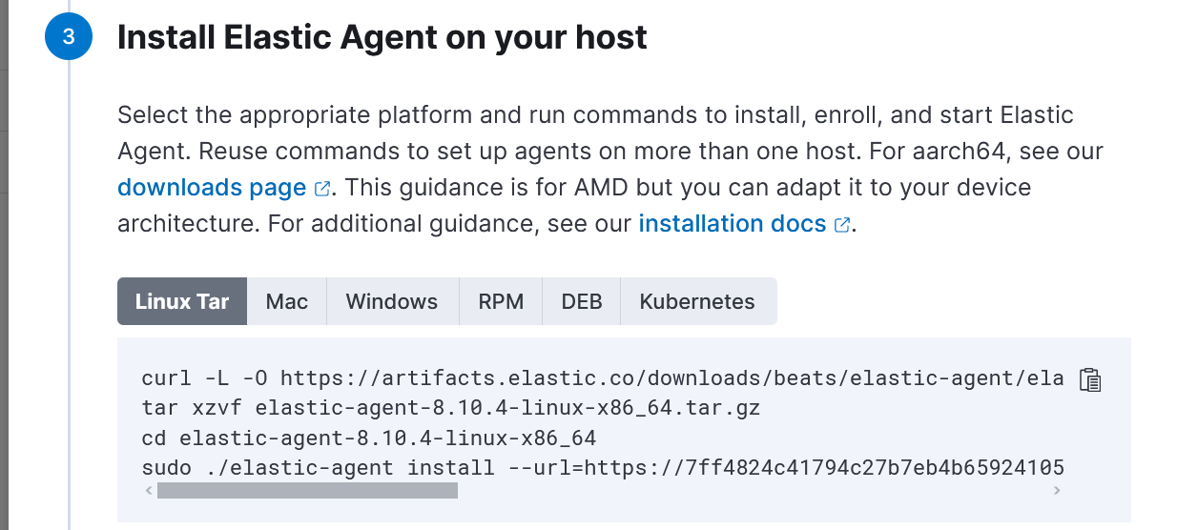

1. 